6A^{th} Grade: Unit 15, Lesson 4
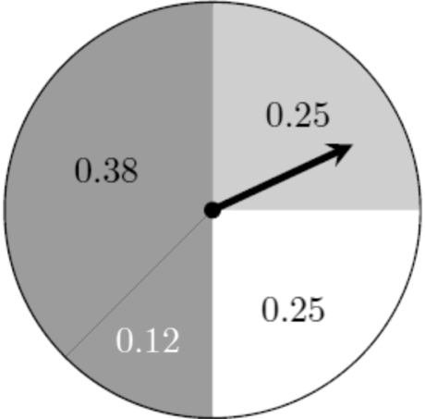
- The spinner displays the probabilities of landing on each of the shades. Use this information, is the following statement true?
“Landing on the darkest shade is less likely than landing on white.”

Yes

- Given events A and B, which one is more unlikely?
- There is a 25% chance that it will rain tomorrow.
- The probability of finding a pearl in a wild oyster is 0.01%.

B

- Arrange the following probabilities from least to greatest: 0.38, 5%, $\frac{45}{50}$

5% < 0.38 < $\frac{45}{50}$

